Curriculum Vitae

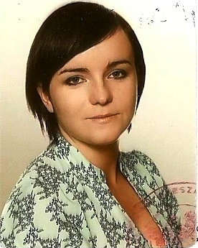
Marta Szarek
34-733 Mszana Górna
325
tel. (018) 331 52 26
tel. kom. 886185788
e-mail martha-19@o2.pl
unmarried

University Qualifications

2010-now Student of Business English in Wyższa Szkoła Zarządzania
Marketingowego I Języków Obcych in Katowice.

2008-2011 Student in Podhalańska Państwowa Wyższa Szkoła
Zawodowa in Nowym Targu
Specialisation: physiotherapy

2005-2008r. B.A. In English language, Maria Curie-Skłodowska University,
Lublin

Employment history:

June-August baby-sitter in Chicago, USA..
2004

June-September Shop-assistant in Shell Petrol Station in Ballinasloe, Ireland
2006 and 2007

June-September Working in Harney’s Dry Cleaners in Ballinasloe, Ireland
2007 rok

January 2009 2 weeks practice as a physiotherapist in a hospital in Limanowa

March-May 2009 1st and 2nd degree Massage course

June 2009 Course for counselors, trainers & educators working in youth
and children’s leisure and recreation environment that was
organised by the Tourist Agency Gaudeamus

July 2009 5 weeks practice in Health Service Centre in Mszana Górna

PERSONAL QUALITIES
Computer literate, adaptable, organised, quick learner, ability to work well under stress, good sense of humour.

Languages
Polish - native, English - fluent, German – basic, Russian - basic

